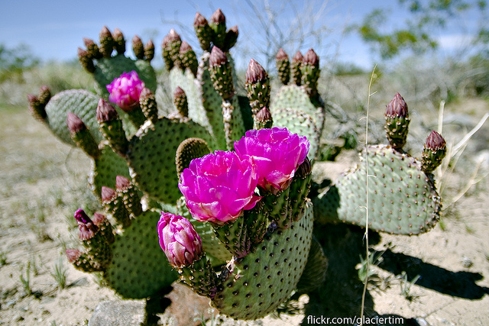 |  | Grow with us in 2019!
Blooming Sleeping Room Rates starting at $79.00  If booked by May 31st 2019  (15 room minimum)  Thomas James  PHONE:  480-387-5911  WEBSITE:  Graduatetempe.com  EMAIL:  tjames@graduatetempe.com  Hobbies  Day Meetings  Social Hours  Receptions  Retreats  Sleeping overs  Staycations |  | EDUCATION  Graduate Tempe Hotel, Tempe , AZ Opened October 2015  Value Offers Dates: May-August 2019  2018 - 2019 Property Advancements; Renovated Food and Beverage options Normal Pool, Restaurant and Rooftop Featuring Bianco Food Group; Refreshed Pool area with on going enhancements in 2019  WORK EXPERIENCE  Simple Orientation Instructor May 2019- August 31th 2019  $69.00 package includes:  Continental Breakfast  Afternoon Break service  Audio Visual (Screen, Easels, Podium, power cords)  Lunch (selection of Deli, Taco Bar or Italian)  Complimentary Parking  Price is per person Plus tax and 22% Service Charge  15 person minimum  Additional Skills and Qualifications  These are great Value Additions;  Full Breakfast Buffet 5.00 ++  Full Day Break Service 5.00 ++  Happy Hour Beer Margarita reception 10.00++

